Medicare and Medicaid: Study in Benefits for Consumers in NY & MA

Cynthia, Ernesto, Nithya, Yisha
Masters in Data Science, Southern Methodist University
E-mail : YishaW@smu.edu, ecarreraruvalcaba@smu.edu, alvaradoc@mail.smu.edu, ndevadoss@mail.smu.edu

Abstract: The Center for Medicare & Medicaid Services (CMS) website provides information regarding qualified healthplans [1]. The plans for the states of New York and Massachusetts are compared in terms of their quality using the average actuarial value .

1. Related Work
CMS provides detailed information regarding the benefits, coverage limits, cost sharing, rates based upon subscriber’s age, tobacco use and geographic location, plan attributes, out-of-pocket payments, deductibles, cost sharing, HSA eligibility, business rules, geographic coverage areas and provider network URLs. This information allows researchers to conduct in-depth analyses of the qualified health plans offered across the United States.
Kaulkar et al. [2] have examined the average Deductible Amount for Medical and Drug Essential Health Benefits (EHB) Plan and other features of the health plans for all the states in the country. However, it does not give a quick summary on what are the states with the best plans. Therefore, this paper aims to identify a metric that can easily quantify the quality of the plan offered by the states. To ease the comparison, we have selected to conduct the comparison between 2 states, Massachusetts and New York.

2. Introduction
According to Forbes [3], the United States spends more on health care than any other comparable country, with a very mediocre return on investment. The high costs of healthcare services put a burden on the premiums, deductibles, copayments that insurance companies need to establish when designing healthcare plans.
Moreover, local and federal regulations have also an influence in the costs of healthcare insurance plans. For example, when the Affordable Care Act (aka “Obamacare’) was signed into law by President Obama on March 2010, required access to uninsured individuals with pre-existing conditions. In this environment with costly insurance, consumers need to have the elements to make educated decisions for selecting the best plan that fits their budget while covering their healthcare needs. PricewaterhouseCooppers recently published the results of a survey conducted in 2016 in which they identified the 3 main concerns that consumer have regarding health insurance plans. The top 3 items are (in order of importance): cost of monthly premium, coverage of services and medications and doctors and hospitals included in the network. The lack of good coverage in a healthcare insurance plan can be very detrimental in consumer’s economy given the high costs of healthcare. The higher the coverage that a plan can provide the lower the likelihood of a consumer goes bankrupt due to healthcare expenses. In this paper, we aim to provide a quick summary of the quality of coverage provided by insurance health plans using the actuarial value. The actuarial value is the ratio of the the total expected payments by the plan for essential health benefits over the total expected costs of the "standard" population for essential health benefits. Thus, the higher the percentage, the better the plan, as they are typically expected to pay more on the member’s behalf, thus reducing the out-of-pocket cost.
Kaulkar et al. [2] put special effort on describing the plans by their features, such as, average deductible per state, number of plans having a coinsurance of more than 50%, number of plans with more than 10 EHB benefits, rates by tobacco usage, rates across the state. Moreover, they attempt to provide a model using linear regression for the following relationships: individual rate vs age groups, number of benefits vs individual premiums, individual premium rate vs number of benefits provided, individual rate vs age group. However, it is not completely discussed how the quality of coverage provided by health insurance plans differs across the states. The focus was put on comparing two states fro which it is assumed they provide the same type of healthcare insurance plans. The map presented below is extracted from the Kaular et al [2] work in which it is shown the Average Deductible for Medical and Drug EHB Plans:
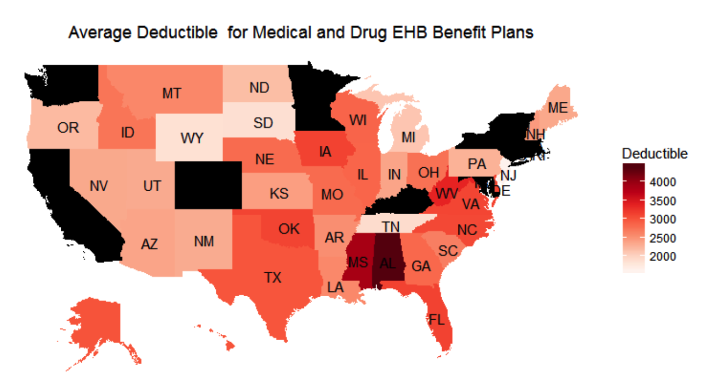
Figure 1 Average Deductible for Medical and Drug EHB Benefit Plan

The darker the color the higher the average amount deductible paid for consumers in each state. It is important to highlight that high income states such as California, Washingtong, New York and Massachusetts exhibit very high average deductible amount. We will assume that the the states that on average are paying more deductible should have the highest actuarial value or in other words, plans with the highest coverage. Therefore, these states consitute the first filter of the states to be analyzed. Since the mail goal of the paper is just to select 2 states and compare the actuarial value and other important features, the second assumption was to select states that are geographically close to each other. Therefore, the states selected for the analysis are New York and Massachusetts since they are geograhically close to each other and exhibit a high average deductible.

3. Data Description
The data was gathered from the CMS website, selecting the states of New York and Massachusetts individually. The two files were combined into one file, and the primary table was created from that data. The table containes 60 attributes, with approximately 4,220 plan records. The attribute description can be found in full detail [5]. Full codes and write ups can be found at github.com/ndevadoss/7330-TermProject.

4. Data Cleanup
The raw data had duplicates based on plan_id. We cleaned the data by keeping the plan_id as unique before we ran the analysis. We updated the issuer_actuarial_value to a percentage format, and defaulted the plan expiration date to '2016-12-31' for instances of missing data. We were able to change the format of the Issuer_Actuarial_value in two ways. The first method is using the “update” function and replace the ‘6199%” format to ’61.99%’ format. The second method was to define the variable as a decimal (5,2) when creating the table. The “update” function was also used to standardize the expiration date to ‘2016-12-31

5. Data Analysis
Over all, there are 69 distinct plans available in Massachusetts and 1198 in New York as reflected in table 5. Figure 6 is the code used to determine the distinct counts of plans. In raw data, plans (plan_marking_names) are duplicated as they are multifaceted and each row is a unique combination of plan features. Plans can have many combinations of features. If we took count of all plan names, then it would inflate the real number of plans available.

5.2 Actuarial Values:

Consumers with a higher value for actuarial value is expected to pay less than as consumer of lower value since the insurance company will be covering the difference. In Table 1 shows the actuarial value per plan. The value was pre-calculated by the CMS. Here the maximum and minimum values can be easily identified in the table output. Outputs in Table 1 is calucated from Fig.2 code. Because there are lines of duplicate plan, a “distinct” search of plan and values are implemented. The “trim()” function is implemented to cut off leading and trailing spaces. In addition “substr()” is used to pull values form the string. Consumers reviewing this plan can see that actuarial value range from 0 to 100. From 0, the next value is 59%. This is quiet a jump from no coverage to over half of the coverage.

5.3 Comparing MOOPS Between States:
TEHB INN is the In-Network Total Essential Health Benefits. Based on the results we see that the average MOOP is lower for the state of MA compared to the state of NY. Consumers should also pay attention to MOOP costs when chosing a plan. MOOP is the “Member Out of Pocket” amount in which a member will pay up to a certain amount before insurance covers the rest of the costs of medical sevices per coverage period. As seen in Table 2 and Table 3, the range of MOOP is between $0.00 and $6,850.00. The table also depicts that variance in deductable is based upon Metal_Level. This is not to say that deductable per Metal_Level are the same in each state. However the MOOP maximum for each state is $6,850. In laymens terms, the highest deductable plan a consumer is expected to pay at the most $6,8650 per plan period before insurance is effective. Consumer can clearly pick between which MOOP suits their needs best. For example for MA HMO “Catastrophi” the minium MOOP is $6550 and maximum is $6850. A consumer will need to determine if this difference in decutable is justifiable with the cost of the plan. Key functions used to determine maximums and minimums are the “max()” and “min()” functions.

5.4 Comparison of Average Having Baby Deductable:
The average cost of having a child can range from approximately $11,000 to $21,00 in 2014 [6]. CMS data is based off of 2016 data, in which the figures referenced above should further be accounted for inflation at the least. From the plans provided there is a significant benefit in having insurance as the deductable is averaged at $1,992.47 in Massachusetts and $2,487.40 in New York. Consumers planning to have children should consider these figures when chosing the best plan. We were able to calculate the averages uing the “avg()” function in Mysql Workbench. In addition to knowing the averages, customers can easily pick plans using Figure 9 which shows maximum and minium deductables per metal level. Maximum and minimum values are calculated via “max()” and “min()” functions.

5.5 Graphics:

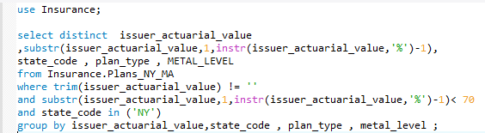
Figure 2 Actuarial Value of Plans.
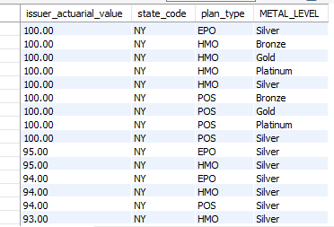
Table 1 Actuarial value query output.

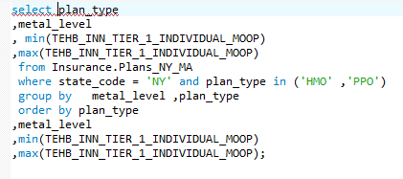
Figure 3 Comparison of maxium and minimum MOOP (member out of pocket) allowables among various Metal Levels in the state of New York query

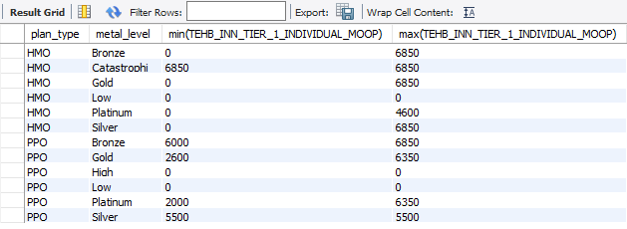
Table 2 Comparison of maxium and minimum MOOP (member out of pocket) allowables among various Metal Levels in the state of New York.

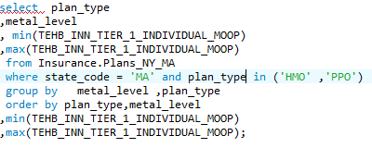
Figure 4 Comparision of maxium MOOP (member out of pcoket) allowables among various Metal Levels in the state of Massachusetts query.

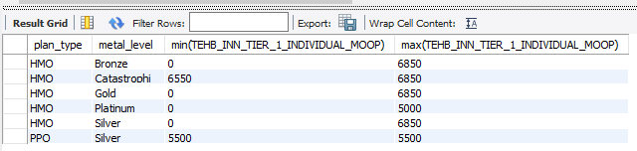
Table 3 Comparision of maxium MOOP (member out of pcoket) allowables among various Metal Levels in the state of Massachusetts.

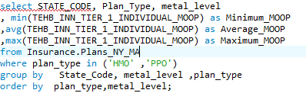
Figure 5 Comprehensive maximum and Minimum MOOP and averages for Massachusetts and New York query.

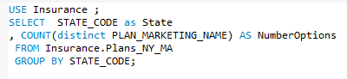
Figure 6 Count of distinct plan available per state query.

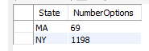
Table 4 Count of distinct plan available per state.

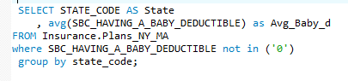
Figure 7 Average cost of deductible per state for due to the birth of child query.

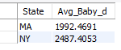
Table 5 Average cost of deductible per state for due to the birth of child.
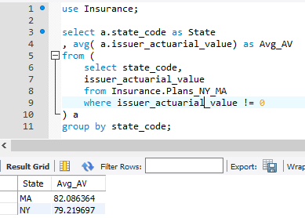
Figure 8 Average Actuarial Value per state.

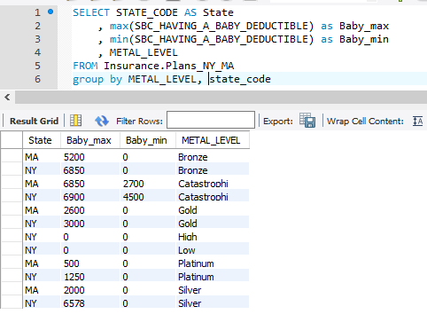
Figure 9 Maximum and Minium Having a Baby Deductable

5. Conclusion:
Despite their geographical proximity and similar average deductible for medical and drug EHB benefit plans, the state of Massachusetts provides better health insurance coverage than New York when comparing the average actuarial value between the 2 states. The actuarial value provides a quick summary of the coverage provided and consumers should take this metric into account when selecting an insurance health plan.

References
[1] https://www.cms.gov/CCIIO/Resources/Data-Resources/sbm-puf.html
[2] https://sonalkaulkar.wordpress.com/analysis-of-health-insurance-marketplace-3/
[3] http://fortune.com/2017/07/10/health-care-in-the-us-problem/
[4] https://www.pwc.com/us/en/health-industries/top-health-industry-issues.html
[5] https://www.cms.gov/CCIIO/Resources/Data-Resources/Downloads/Plan-Attributes-Data-Dictionary.pdf
[6] https://www.nerdwallet.com/blog/health/medical-costs/how-much-does-it-cost-to-have-a-baby/

EHB stands for Essential Health Benefits
Full Link to git hub is: https://github.com/ndevadoss/7330-TermProject

